##### 

Project 4: Degradation of Data Integrity

Diego Guerra & Ryan Scott

CST-305

Dr. Ricardo Citro

**Part 1:**

Using a system of differential equations, we first develop a model for transferring data among processors. As a result of the fact that each processor is composed of a group of processors, we can add up the rate of input supplied by each processor, multiplied by the ratio of data each of these processors contains. To get a total output, we subtract and multiply the processor output.

Our next step is to find the eigenvalues of the matrix created by these DEs:

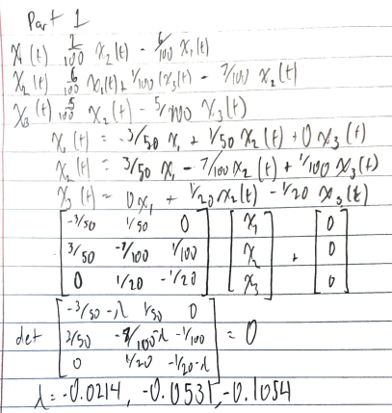

The eigenvalues are: **λ = -0.0214, -0.0531, -0.1054**

Using an online calculator, we solved the third-degree polynomial.

**Part 2:**

Using a system of differential equations, we repeat steps in part 1, making another system of DEs. Our task was to solve for e^At, followed by solving the DE system using the matrix method.

Once e^At is solved, the solution can be found:

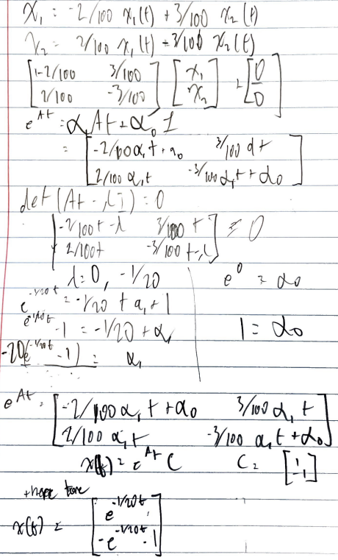

Here is a graph of the solution using Python:

